Chapter 14, Problem 78.

Redesign the circuit in Fig. 14.85 so that all resistive elements are scaled by a factor of 1000 and all frequency-sensitive elements are frequency-scaled by a factor of 10⁴.

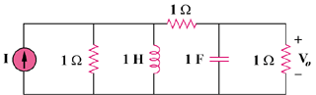

Figure 14.85
For Prob. 14.78.

